- Insert Picture
  - Insert Tab, Illustrations Group
    - Pictures – in your files
    - Online Pictures – Internet

- Insert Shapes
  - Insert Tab, Illustrations Group
    - Shapes, Change colors, Edit Shapes

Hello My Name is

- Insert hyperlink - Coastline Community College Website
  - Insert Tab, Links Group
    - Hyperlink to webpage Coastline Community College
    - Hyperlink to email address Lynn Buller

- Insert SmartArt

- Insert Charts

- Insert Screenshot
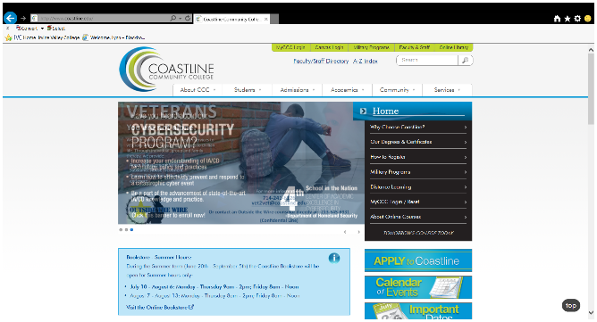

- Insert Bullets:
- Historic interactive timelines
- In-depth photos taken on the set during the making of the film
- Interactive educational games
- Fast facts and flashcards
- Quizzes and essay exams

- Insert Numbered Bullets:
- The title in which you are interested
- The name of the class and subject
- Online tools you would like to see created

- Insert Left Tab and Right Tab with dot lead:
Monday-Thursday 9 a.m. to 3 p.m.
Friday 9 a.m. to 1 p.m.
Saturday 10 a.m. to noon

- Page Borders & Shades
  - Design Tab, Page Borders

- Page Colors
  - Design Tab, Page Color

